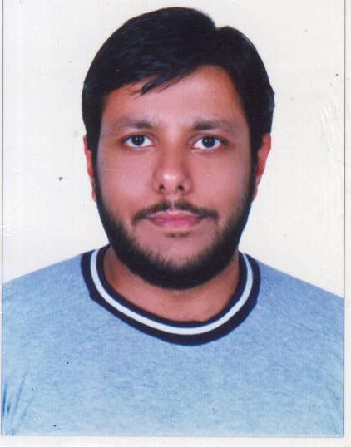**REHAN AHMED PARACHA**

Cell: +971 52 9176406

[rehan.a.paracha@hotmail.com](mailto:rehan.a.paracha@hotmail.com)

Skype: rehan.a.piracha

Passport # AM3963461

Nationality: Pakistani

Martial Status: Married

Driving License: Under Process

Ajman-UAE

# CAREER SUMMARY

* More than 5 years of extensive marketing experience to offer but not limited to purchasing, negotiation, quality control, customer service, documentation and booking cargo with shipping company.
* Skilled in needs assessment, problem resolution, cost analysis, price structuring, order expediting, inventory tracking and budget administration; coordinate and prioritize multiple tasks.
* Determine and meet specific client needs to achieve business and financial goals.
* Marketing & strategic execution– Ability to research and recognize growth potential through market analysis.

# CORPORATE EXPERIENCE SUMMARY

**Sales Administrator Dec 2012 - Present**

**Emirates Industrial Filters LLC**

**UAE**

As Sales Administrator, I am responsible for processing all sales-related paperwork and arranging appointments for Sales Manager to visit new and established customers. Specific responsibilities include dealing with invoices, chasing up overdue payments and monitoring ongoing orders & export documentations

*Some of my key responsibilities include:*

* Responsible of handling and maintaining the inquiries from both, vendors and purchasers
* Maintaining the current and accurate customer or client files and records, as well as essential information
* Processing the paperwork generated by sales and scheduling appointments for Sales Manager to make site visits to existing customers or new customer & also keeps records of any site visits made
* Update and efficiently maintain the delivery and shipment schedules of the organization, and coordinate with the customers
* Also prepares estimates for a product if requested by a customer and closely monitors the progress of ongoing orders
* Communicated with various domestic clients and international clients for maintaining the order and delivery status
* Look after the details of every purchase order, and invoices generated in the organization and process the sales orders
* Updated records of sales figures on a weekly basis for comparison purposes with sales & revenue targets for the company
* Responsible for processing invoices, setting up payment accounts via bank transfer or credit card and investigating overdue payments

**Assistant Export Sales Manager Jan 2012 – Oct 2012**

**Ukrani International**

**Pakistan**

As Assistant Export Sales Manager, I was responsible for handling Middle-Eastern and African clients of agriculture products mainly Pakistan rice varieties. I was involved regularly with local market brokers, suppliers and waste buyers to ensure procurement of raw material at the best rates for maximum profit. I was also directly involved in QC of rice due to sound rice knowledge background and also constantly interacting with SGS to ensure necessary standards were followed in terms of quality.

*Some of my key responsibilities include:*

* Marketing food items in middle-east countries, correspondence and negotiations, booking orders, quality control and establishing long term relation with buyers.
* Planning and development for new markets.
* Time managed delivery of goods.
* Documentation: Letter of Credit preparation, export and shipping related documentations.

**Export Sales Officer Dec 2009 – Dec 2011**

**Mars International**

**Pakistan**

As Export Sales Officer, I was responsible for the company’s export documentation which includes Letter of Credit, delivery schedules, and maintained relationship with shipping company for timely shipment.

*Some of my key responsibilities included:*

* Responsible for the execution of export documentation requirements for shipments originating in the Pakistan to destinations globally.
* Communicate with export related authorities, and customers, in all relevant territories and countries.
* Monitored and interpreted business/foreign vendor trends, including foreign labor costs, product availability, shipping routes and political situations.
* Keep track of invoices and prepare reports to expedite the billing process.
* Developed a daily report to track the number of shipments.

**Immigration Consultant June 2009 – Nov 2009**

**Westland Multi Services**

**Pakistan**

As an Immigration Consultant, I was responsible for dealing with the existing as well as new customers, giving brief information to the walk in customers about immigration, maintaining client’s data and follow up on daily basis, preparing immigration documentations.

*Some of my key responsibilities included:*

* Deal with visiting Clients daily & fill an assessment Form.
* Prepare Immigration documents for each Client for different Countries such as Canada, UK, Malaysia, and Australia etc.
* Prepare Covering letters for Clients as well as for Embassy of different Countries.
* Prepare broachers for Canada, UK, Malaysia, Australia etc.
* Maintain documentation of each client manually as well as in database management system.
* Prepare assessment Form, Payment Form etc. for Clients as well as for Employees of Westland.

**Internee July 2008 - Aug 2008**

**Pakistan State Oil**

**Pakistan**

As Internee, I was responsible for maintained accounts for clients and gain knowledge about corporate, fleet cards and also deal in memos of these cards, also maintained data related to billing of cards for different sector.

**Internee July 2007 - Aug 2007**

**Habib Bank Limited**

**Pakistan**

As Internee, I was rotated in different department such as Tele-Marketing, Credit and Finance, Remittance & General Banking Operations.

# ACADEMIC QUALIFICATIONS

Bachelor in Business Administration (BBA-Finance)

# PROFESSIONAL & TECHNICAL SKILLS

* Extensive use of Internet and Email, Net based research etc.
* Full command on MS Office.
* Presentation skills and proposal development.
* Ability to succeed in high-pressure environments under deadlines
* Good multi-tasking & organizational skills
* Outstanding communication skills via professional writing & language